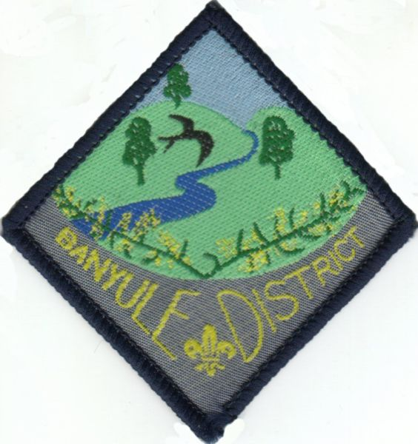

Banyule District Air Activity Day 2009
Trip Details
  What to bring
   | Bring a bag, Drink bottle, Helmet, Sun cream.  Make sure that you wear your Cub Shirt and scarf on the day and closed shoes. No sandals please.
   | Note: No radio, cell phone, or other electronic device is allowed on this trip. Any equipment of this kind will be taken away by the Leaders and returned at the end of the event.
Starting Point | Moorabbin Airport  Second Avenue
Date | November 21st
Time | Please have your child at the Airport no later than 9.30 A.M. Finishing at 12.30
Transportation | Parents Cars.
Cost | $45.00 per Cub Scout for a Flight, Activities & badge.
Notes | Leaders will be there.  Parents are welcome to stay.  Please advise if you would like a flight.

Cut off bottom portion of permission slip and return to Akela by 18th November.
Expression of Interest / Permission
Please bring a completed Medical/Health Form (see http://www.rosannacubs.org/paper.htm )
Name Youth / Parent Group

Enclosed is $45.00 each to cover expenses. Please write cheque Payable to Banyule District Cubs

X
Parent or guardian signature Date

Special Instructions:

